**Relational Database Schema Design:**

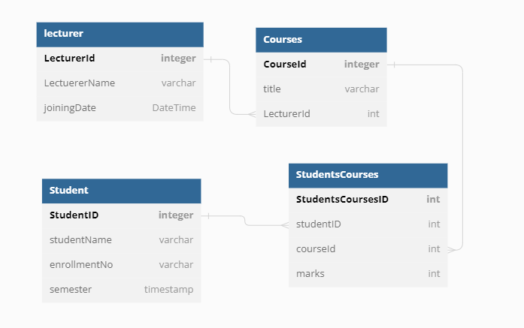

**Relational Schema:**

**Table lecturer** {

  LecturerId integer [primary key]

  LectuererName varchar

  joiningDate DateTime

}

**Table Student** {

  StudentID integer [primary key]

  studentName varchar

  enrollmentNo varchar

  semester timestamp

}

**Table Courses** {

  CourseId integer [primary key]

  title varchar

  LecturerId int

}

**Table StudentsCourses** {

  StudentsCoursesID int [primary key]

  studentID int

  courseId int

  marks int

}